
Tittle of Project :-
“Student Performance Analysis Dashboard using Data Visualization.”
Branch :- Artificial Intelligence & Data Science.
Team Name :- Analytics Squad
Name of students :-
            - Asavari Gondole (AIDSU24074)
            - Jaya Bhunte (AIDSU24079)
            - Prachi Chorode (AIDSU24088)
            - Sanika Mendhe (AIDSU24095)
            - Mrudula Dahatonde (AIDSU24084)

Guided By :-
Dr. P. G. Angaitkar

Assistant Professor

Department of Artificial Intelligence and Data Science
B. Tech. Second Year- 4th Sem
2025-2026

CERTIFICATE

This is to certify that following group of students of have successfully completed the AI&DS Lab project tittle “Student Performance Analysis Dashboard using Data Visualization” for the requirements of the Bachelors of Technology (B. Tech) program in AI&DS Laboratory during the academic year 2025-2026.

Sr. No Students Name Roll No.
1. Asavari Gondole (AIDSU24074)
2. Jaya Bhunte (AIDSU24079)
3. Prachi Chorode (AIDSU24088)
4. Sanika Mendhe (AIDSU24098)
5. Mrudula Dahatond (AIDSU24084)

Dr. A. G. Angaitkar Dr. A. B. Gadicha
Guide HOD

P. R. Pote Patil Collage of Engineering & Management, Amravati Session 2025-202

Introduction :-
In today’s digital era, data plays a very important role in decision-making, especially in the field of education. Schools and colleges generate a large amount of student data, including marks, attendance, and activity participation. However, analyzing this data manually is time-consuming and complex.
To solve this problem, a Student Performance Dashboard is developed. This dashboard visually represents student data in the form of graphs and charts, making it easy to understand patterns and trends. It helps teachers, students, and institutions to monitor academic performance effectively and take necessary actions for improvement.

Objective :-
The main objective of this project is to analyze and visualize student performance using an interactive dashboard. It aims to provide a clear understanding of academic results and student activities.
Another objective is to compare subject-wise performance so that strong and weak areas can be identified. The dashboard also helps in tracking attendance and participation in extracurricular activities. Additionally, it supports decision-making by highlighting top-performing students as well as those who need improvement.

Outliers :-
Outliers are the data values that differ significantly from the majority of the dataset. In the student performance dashboard, outliers are identified as students who have either very high or very low scores compared to others. These values do not follow the general trend and stand apart from normal observations.
In this analysis, students scoring above 500 marks are considered high outliers, as they perform exceptionally well compared to the average range of students. On the other hand, students scoring below 350 marks are considered low outliers, indicating weaker performance and the need for improvement. These extreme values help in identifying both top-performing students and those who require additional support.
Similarly, outliers can also be observed in attendance and activity participation. Students with very high attendance (above 95%) or very low attendance (below 65%) are considered attendance outliers. In terms of activities, students who participate in many activities or none at all also represent unusual patterns in the dataset. Overall, outliers play an important role in data analysis as they highlight exceptional cases. They help educators focus on high achievers as well as students who may need extra attention, thereby improving overall academic performance.

Dataset Description :-
The dataset used in this project consists of information about 100 students. It includes various attributes such as student names, marks obtained in subjects like AI&DS, CN, IoT, Mathematics, OS, and Python.
Apart from academic scores, the dataset also contains attendance percentage, city of students, and their participation in activities such as workshops, quizzes, sports, and seminars. Grades are also assigned based on performance. This dataset provides a complete overview of both academic and extracurricular aspects of students.

Dashboard Components :-
The dashboard consists of multiple components that help in analyzing student performance effectively. It includes a student filter panel that allows users to select individual students for detailed analysis.
There are different charts such as a donut chart for city-wise distribution, bar graphs for subject performance, and pie charts for grade distribution. A histogram is used to represent attendance distribution, while a line chart shows score trends.
Additionally, the dashboard displays key metrics like total students, highest score, and lowest score. It also highlights the top-performing students, making it easy to identify academic excellence.

Methodology :-
The methodology of this project begins with the collection of student data from a CSV file, which includes details such as marks, attendance, and personal information. The data is then preprocessed using Pandas, where missing values are handled, duplicate records are removed, and columns are converted into proper numeric formats to ensure accuracy and consistency.

After preprocessing, interactive filters such as city, gender, and student name are applied using Streamlit, allowing users to explore the data dynamically. Key performance indicators like total students, average score, attendance, and top-performing students are calculated to analyze overall performance effectively.

Finally, the processed data is visualized using Plotly through charts like bar graphs, pie charts, and scatter plots for better understanding. All these elements are integrated into a Streamlit dashboard, which presents the insights in an interactive and user-friendly manner.
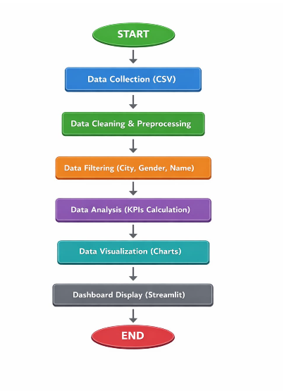
Dashboard Components :-
The dashboard consists of multiple components that help in analyzing student performance effectively. It includes a student filter panel that allows users to select individual students for detailed analysis.
There are different charts such as a donut chart for city-wise distribution, bar graphs for subject performance, and pie charts for grade distribution. A histogram is used to represent attendance distribution, while a line chart shows score trends.
Additionally, the dashboard displays key metrics like total students, highest score, and lowest score. It also highlights the top-performing students, making it easy to identify academic excellence.

Results and Analysis :-
The Student Performance Dashboard successfully analyzes and visualizes the dataset after proper data cleaning, resulting in 99 valid student records. Key metrics such as average score (424.2) and average attendance (77.63%) provide a quick overview of overall performance.
The analysis shows that Python is the highest scoring subject, while IoT has the lowest scores, indicating areas of strength and improvement. The grade distribution reveals that most students fall under Grade B, showing average performance.
The attendance vs total score graph indicates that students with higher attendance generally achieve better scores. The subject-wise distribution highlights variation in marks across different subjects, while activity participation shows balanced student involvement.
Overall, the dashboard effectively converts raw data into meaningful insights, helping in understanding student performance and trends.

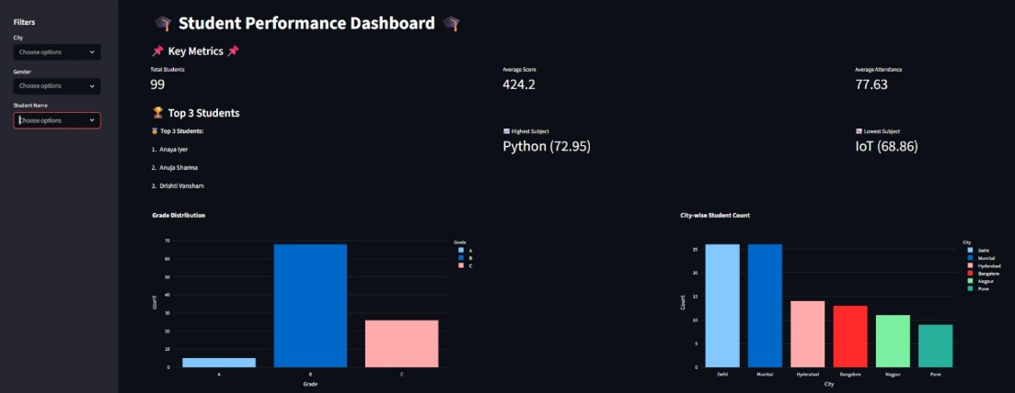
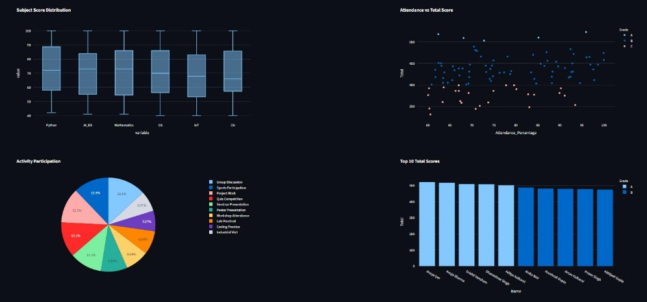
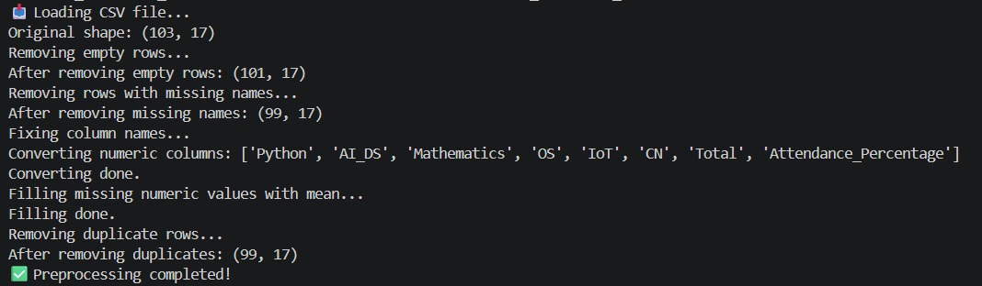
Tools and Technologies Used :-
Python serves as the core technology for developing the dashboard, providing a flexible and efficient environment for data analysis and processing. It allows smooth integration of different libraries and helps in handling large datasets with ease, making the overall development faster and more reliable.
Pandas and NumPy play a crucial role in managing and processing the data, where Pandas is used for cleaning, organizing, and transforming the dataset into a structured format, while NumPy enables fast numerical computations and supports complex mathematical operations required for accurate analysis.
For visualization, Matplotlib and Plotly are used to create graphs and charts that represent the data in a clear and meaningful way; Matplotlib helps in generating basic static charts, whereas Plotly provides interactive and dynamic visualizations, allowing users to explore insights easily, while CSV files are used for storing data and Exploratory Data Analysis (EDA) techniques help in identifying patterns, trends, and important information within the dataset.
Future Scope :-
The Student Performance Dashboard can be improved by adding real-time data updates, which will allow the system to automatically refresh whenever new student data is entered. This will make the dashboard more dynamic and useful for continuous monitoring of student performance.
In the future, Artificial Intelligence and Machine Learning can be integrated to predict student performance and identify weak students in advance. This will help teachers take early action and provide better guidance to improve results.
The dashboard can also be made mobile-friendly and integrated with school management systems. Additional features like personalized student reports and performance comparison will make the system more interactive and beneficial for both students and teachers.

Conclusion :-
In conclusion, the Student Performance Dashboard is an effective tool for analyzing and visualizing student data. It simplifies complex data into easy-to-understand visuals, helping users quickly identify trends and patterns.
The dashboard not only improves understanding of student performance but also supports better decision-making. It can be used by teachers and institutions to enhance learning outcomes and guide students towards improvement.

